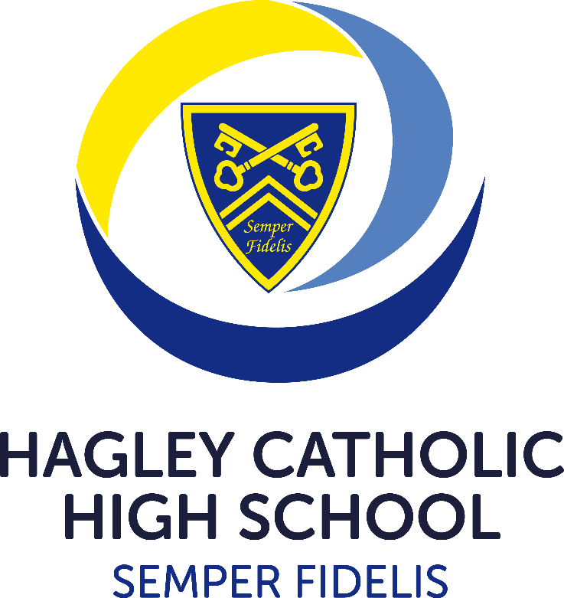

TRANSPORT INFORMATION 2024/25

**Travelling by Train**

If you live near a station on the Birmingham to Hereford line, you can apply online for a **Student Season Ticket** with West Midlands Railway. Thisis cheaper than passes available to purchase at the stations.

Applications for Student Season Tickets should be made via [Termly Student Discount Train Ticket | Train Ticket Types (westmidlandsrailway.co.uk)](https://www.westmidlandsrailway.co.uk/tickets-discounts/discounts/student-season-train-tickets) The tickets cover travel for a whole academic term and are priced as follows:

Students aged 16 or over - 50% discount on the usual adult season ticket price

Students aged 15 or under – 25% discount on the usual child season ticket price

Valid evenings, weekends and school holidays: travel when the schools, colleges or universities are closed.

Student Season Tickets must be accompanied by a photocard and student ID whilst travelling. Photocards can be requested as part of the order process.

Lost season tickets can be replaced by West Midlands Railway. Please refer to their website for further details.

For details of stations on the West Midlands Railway network please refer to [Our Route Maps and Rail Network (westmidlandsrailway.co.uk)](https://www.westmidlandsrailway.co.uk/travel-information/journey-planning/network-maps)

For current timetable information refer to West Midlands Railway [Downloadable Train Timetables and Schedules (westmidlandsrailway.co.uk)](https://www.westmidlandsrailway.co.uk/travel-information/journey-planning/timetables)

Should a student leave any belongings on a train, they should contact West Midlands Railway via [Lost property | West Midlands Railway](https://www.westmidlandsrailway.co.uk/contact-us/lost-property)

**Travelling by Public Bus from Stourport, Bewdley & Kidderminster direction.**

**From Stourport to Kidderminster**  Diamond Bus 15A or C

**From Bewdley to Kidderminster** Diamond Bus 8, Diamond Bus 292, Yarraton Brothers 291

**From Kidderminster to Hagley** Diamond Bus 192

Please refer to the Diamond Buses website directly for up-to-date information on services, tickets and fares

<https://www.diamondbuses.com/bus-services/?region=Worcestershire>

**Travelling by Dedicated School Bus**

**Operated by Endeavour Coaches,** the number of buses, number of stops and timings is dependent on the number of students using the service for any academic year and is subject to change. Three routes are offered (HC2, HC3 and HC4).

Please see Appendix A for bus routes and timetables and the school website for current route maps. For online ticket purchase please use the links provided in the **Hagley Catholic High School – Home to School Transport Guide** from Endeavour Coaches

[Hagley Catholic High School - Transport (hagleyrc.worcs.sch.uk)](https://www.hagleyrc.worcs.sch.uk/Page/Detail/transport-1)

Travel Assistance

Pupil premium students can apply directly to the school to be considered for financial support for school travel (up to 20% of the total cost). Applications should be made using the Pupil Premium Funding Support Request Form, which can be found on the school website at [Hagley Catholic High School - Pupil Premium & Free School Meals (hagleyrc.worcs.sch.uk)](https://www.hagleyrc.worcs.sch.uk/Page/Detail/pupil-premium-and-free-school-meals) Proof of payment, details of transportation and evidence of identity and personal bank account details will be required.

Parents of pupils residing within Dudley Metropolitan Borough Council (MBC) can apply for transport assistance if they are entitled to Free School Meals (FSM)* or if they are receiving maximum rate of Working Tax Credits and Hagley Catholic High School is their nearest Catholic High School. Applications for bus passes in these circumstances should be made via Dudley MBC at [Education Travel Support | Dudley Council](https://www.dudley.gov.uk/residents/learning-and-school/education-travel-support/)

Worcestershire parents entitled to Free School Meals or receiving the maximum rate of Working Tax Credit should enquire about transport assistance at [School and college travel | Worcestershire County Council](https://www.worcestershire.gov.uk/schools-education-and-learning/school-and-college-travel)

Parents of pupils residing within Sandwell can contact Sandwell Metropolitan Borough Council for further information regarding assistance with transport costs [Help with school travel costs | Sandwell Council](https://www.sandwell.gov.uk/info/200151/education_benefits/2179/help_with_school_travel_costs)

Parents of pupils residing within Birmingham can contact Birmingham City Council for further information regarding assistance with transport costs [School travel | Birmingham City Council](https://www.birmingham.gov.uk/info/50052/school_travel)

*\*Entitlement to Free School Meals does NOT automatically transfer when a student moves from Primary School to Secondary School ALL Hagley Catholic High School Students currently eligible for Free School Meals should register with Worcestershire Children’s First to ensure that their entitlement continues. All new applications should also be made via* [*https://www.worcestershire.gov.uk/schools-education-and-learning/free-school-meals*](https://www.worcestershire.gov.uk/schools-education-and-learning/free-school-meals)

